**Assignment 3 & 4**

**IPL MATCH DATASET QUERIES**

* import pandas as pd

# Load the IPL dataset

ipl_data = pd.read_csv('ipl_data.csv')

ipl_data

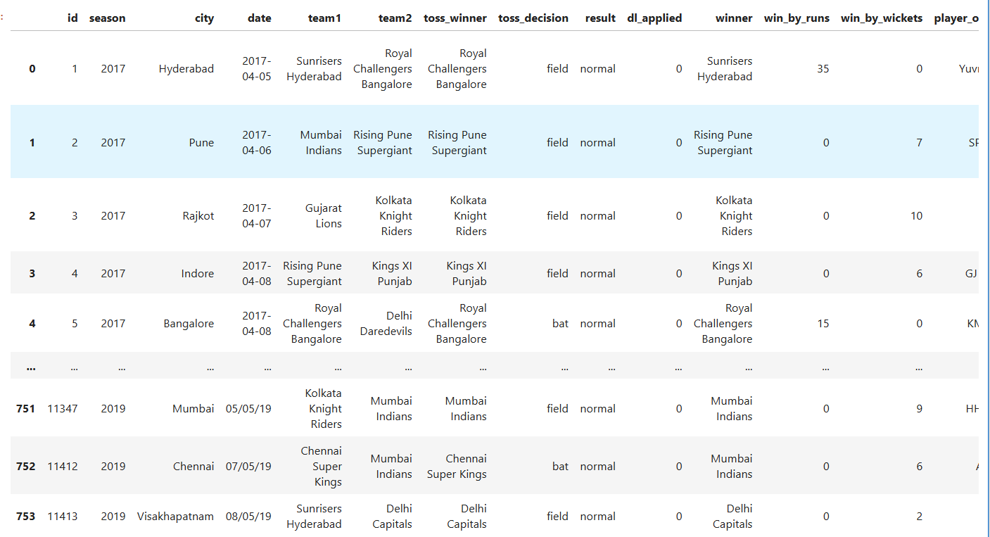

1. **Display the first few rows of the dataset**

*ipl_data.head()*

**Output-**

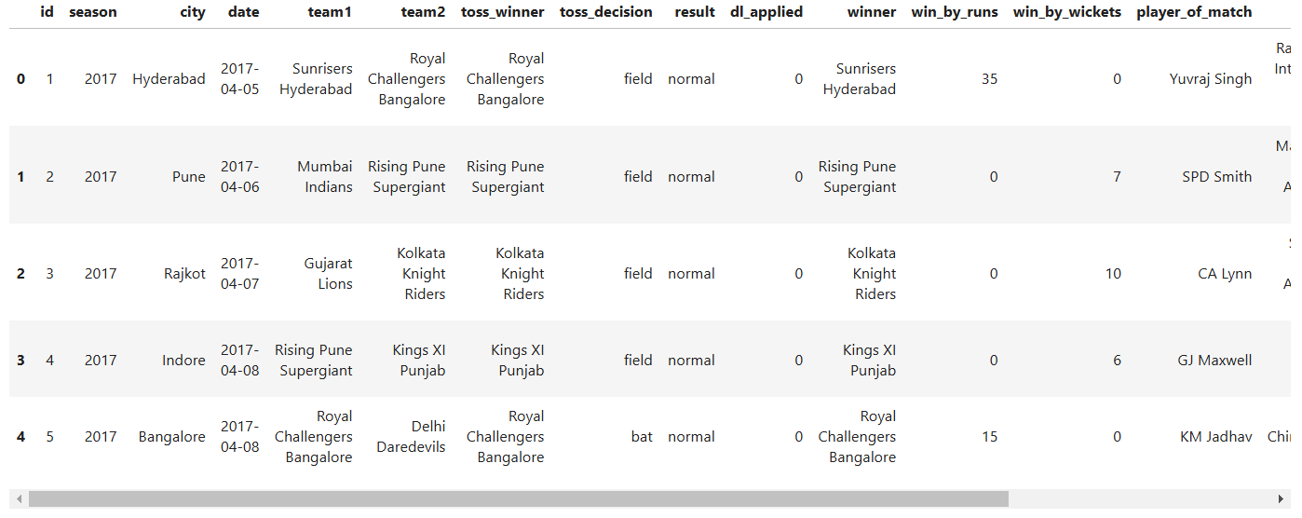

1. **Display the last 5 rows of the DataFrame**

ipl_data.tail()

**Output-**

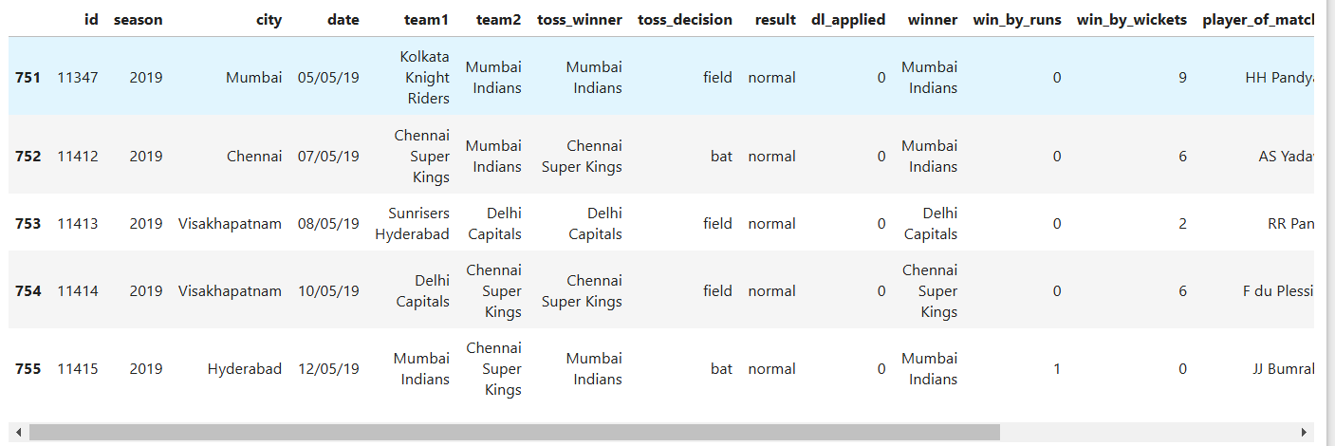

1. **Get the shape of the DataFrame (number of rows and columns)**

print(ipl_data.shape)

**Output-**



1. **Get the data types of each column**

print(ipl_data.dtypes)

**Output-**

1. **Rename a column (e.g., renaming 'team1' to 'Home Team')**

ipl_data.rename(columns={'team1': 'Home Team'}, inplace=True)

ipl_data

**Output-**

1. **Rename the 'team1' column to 'Home Team'**

ipl_data.rename(columns={'team1': 'Home Team'}, inplace=True)

# Display unique values in the 'Home Team' column before replacement

print("Before Replacement:")

print(ipl_data['Home Team'].unique())

# Replace 'Delhi Daredevils' with 'Delhi Capitals' in the 'Home Team' column

ipl_data['Home Team'] = ipl_data['Home Team'].replace('Delhi Daredevils', 'Delhi Capitals')

# Display the updated unique values in the 'Home Team' column to confirm the change

print("\nAfter Replacement:")

print(ipl_data['Home Team'].unique())

# Display the first few rows of the DataFrame to see the changes

print("\nUpdated DataFrame:")

print(ipl_data.head())

**Output-**

1. **Use the `str.contains` method to filter teams with 'Royal' in their name**

royal_teams = ipl_data[ipl_data['team1'].str.contains('Royal', na=False)]

print("\nTeams with 'Royal' in their name:")

print(royal_teams[['team1', 'team2']].head())

**Output-**

1. **Use the `pd.to_datetime` method to convert a column to datetime format and extract the year**

ipl_data['year'] = pd.to_datetime(ipl_data['date']).dt.year

print("\nDataFrame with extracted year from date:")

print(ipl_data[['date', 'year']].head())

**Output-**

1. **Use the `groupby` method to get the total number of matches played by each team**

matches_played_by_team = ipl_data.groupby('team1').size() + ipl_data.groupby('team2').size()

print("\nTotal matches played by each team:")

print(matches_played_by_team)

**Output-**

1. **Get a summary of the DataFrame (descriptive statistics)**

print(ipl_data.describe())

**Output-**

1. **Check for missing values in the DataFrame**

print(ipl_data.isnull().sum())

**Output-**

1. **Drop rows with missing values**

ipl_data.dropna(inplace=True)

ipl_data

**Output-**

1. **Select a specific column (e.g., 'winner')**

winners = ipl_data['winner']

print(winners.head())

**Output-**

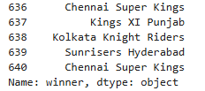

1. **Select multiple columns (e.g., 'season' and 'winner')**

selected_columns = ipl_data[['season', 'winner']]

print(selected_columns.head())

**Output:-**

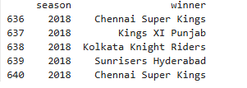

1. **Filter rows based on a condition (e.g., matches won by 'Mumbai Indians')**

mumbai_wins = ipl_data[ipl_data['winner'] == 'Mumbai Indians']

print(mumbai_wins.head())

**output**

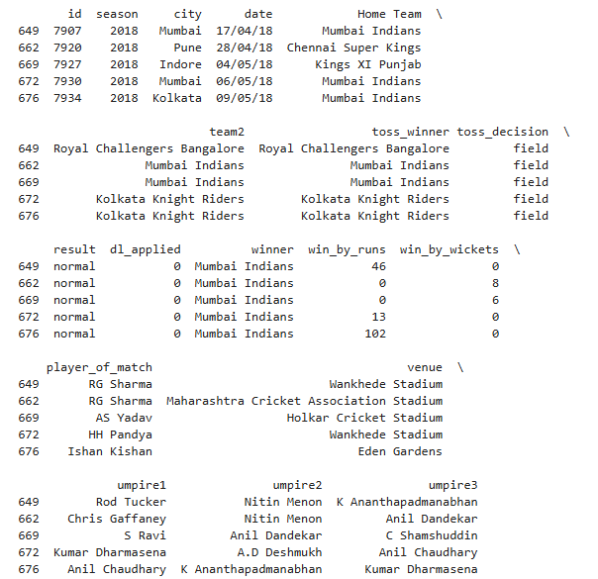

**16. Group by a column and get the count (e.g., count of matches won by each team)**

match_counts = ipl_data['winner'].value_counts()

print(match_counts)

**OUTPUT**

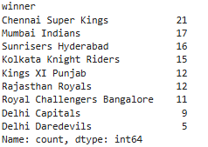

**17. Sort the DataFrame by a specific column (e.g., sorting by 'date')**

ipl_data.sort_values(by='date', inplace=True)

ipl_data

**OUTPUT**

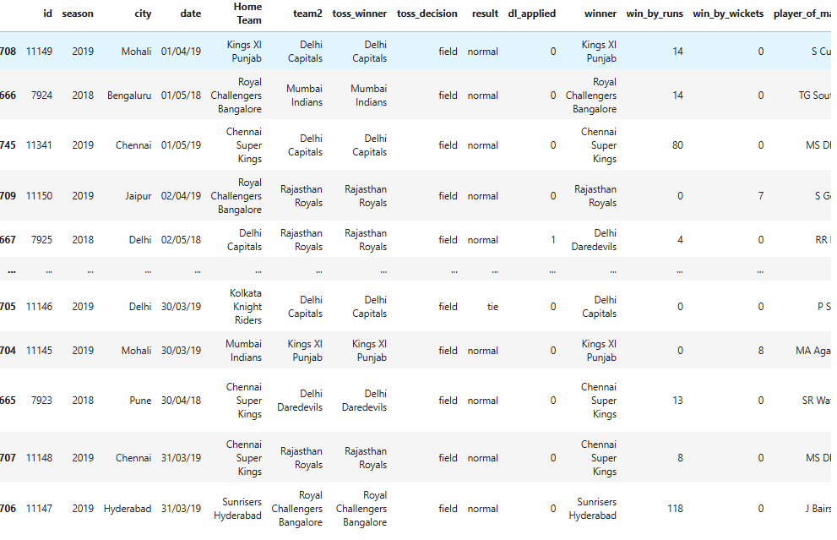

**18. Reset the index after sorting**

ipl_data.reset_index(drop=True, inplace=True)

ipl_data

**OUTPUT**

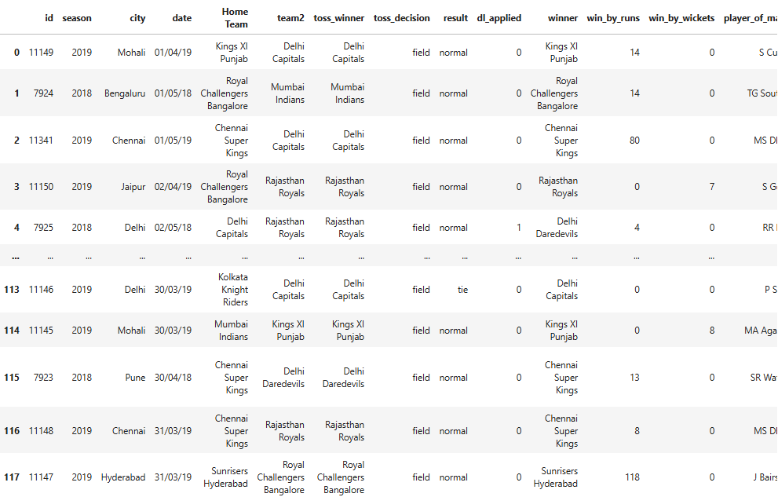

**21. Get the index of the DataFrame**

print(ipl_data.index)

**OUTPUT**



**22. Get the columns of the DataFrame**

print(ipl_data.columns)

**OUTPUT**

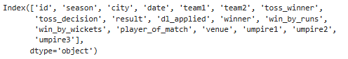

**23. Check the memory usage of the DataFrame**

print(ipl_data.memory_usage())

**OUTPUT**

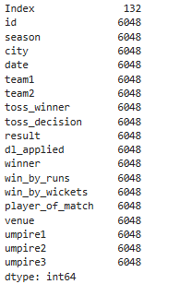

**24. Sample random rows from the DataFrame**

print(ipl_data.sample(5))

**25. Check the first 10 rows of a specific column**

print(ipl_data['venue'].head(10))

**OUTPUT**

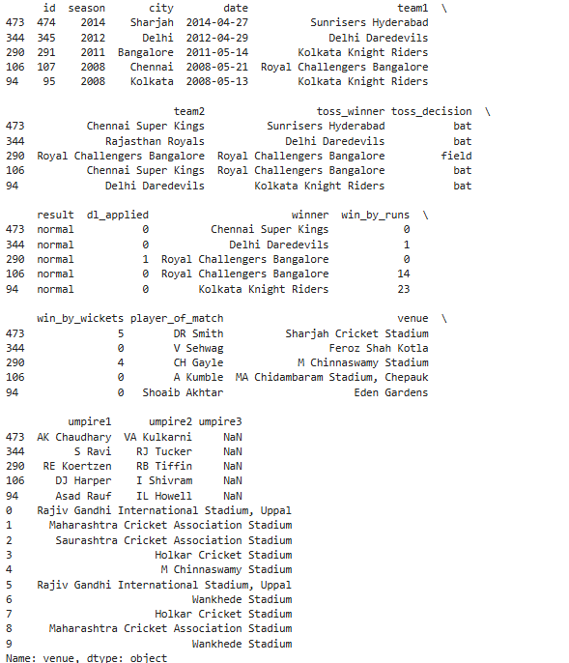

**26. Get the count of unique values in a specific column (e.g., 'venue')**

unique_venue_counts = ipl_data['venue'].value_counts()

print(unique_venue_counts)

**OUTPUT**

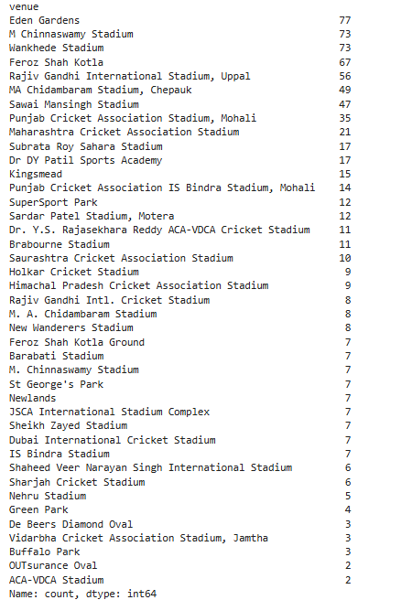

**27. Filter matches played in a specific city (e.g., 'Mumbai')**

mumbai_matches = ipl_data[ipl_data['city'] == 'Mumbai']

print(mumbai_matches.head())

**OUTPUT**

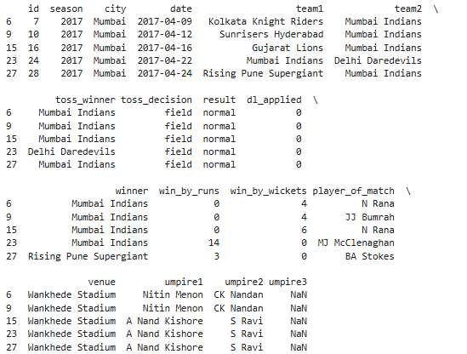

**28. Get the first occurrence of each team in the dataset**

first_occurrences = ipl_data.drop_duplicates(subset='team1', keep='first')

print(first_occurrences[['team1', 'date']])

**OUTPUT**

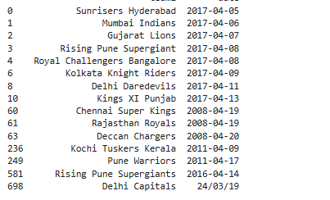

**29. Count the number of matches played in each season**

matches_per_season = ipl_data['season'].value_counts()

print(matches_per_season)

**OUTPUT**

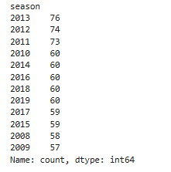

**30. Get the average win margin for each team**

average_win_margin = ipl_data.groupby('winner')['win_by_runs'].mean()

print(average_win_margin)

**OUTPUT**

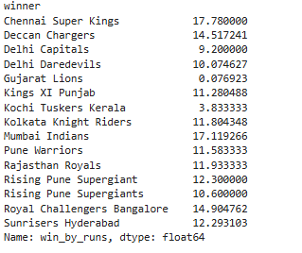

**31. Find the match with the highest win margin**

highest_win_margin_match = ipl_data.loc[ipl_data['win_by_runs'].idxmax()]

print(highest_win_margin_match)

**OUTPUT**

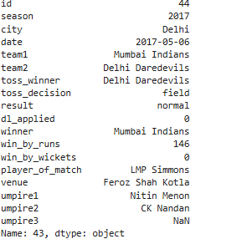

**32. Count the number of matches that ended in a tie**

tie_matches_count = ipl_data[ipl_data['result'] == 'tie'].shape[0]

print(tie_matches_count)

**OUTPUT**



**33. Get the player of the match for all finals**

finals = ipl_data[ipl_data['result'] == 'normal'].iloc[-1]

print(finals[['season', 'player_of_match']])

**OUTPUT**



**34. Get the total number of matches played at each venue**

matches_per_venue = ipl_data['venue'].value_counts()

print(matches_per_venue)

**OUTPUT**

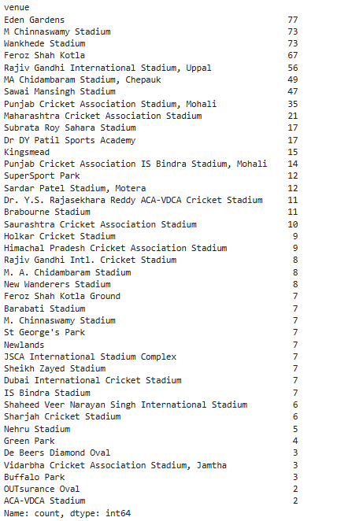

**35. Get the average number of runs scored by the winning team**

average_runs_winning_team = ipl_data.groupby('winner')['win_by_runs'].mean()

print(average_runs_winning_team)

**OUTPUT**

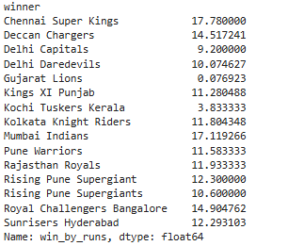

**36. Get the player of the match for the most recent match**

most_recent_match = ipl_data.iloc[-1]

print(most_recent_match['player_of_match'])

**OUTPUT**



**37. Use the `query` method to filter matches where the winning team is 'Mumbai Indians'**

mumbai_wins = ipl_data.query("winner == 'Mumbai Indians'")

print("Matches won by Mumbai Indians:")

print(mumbai_wins)

**OUTPUT**

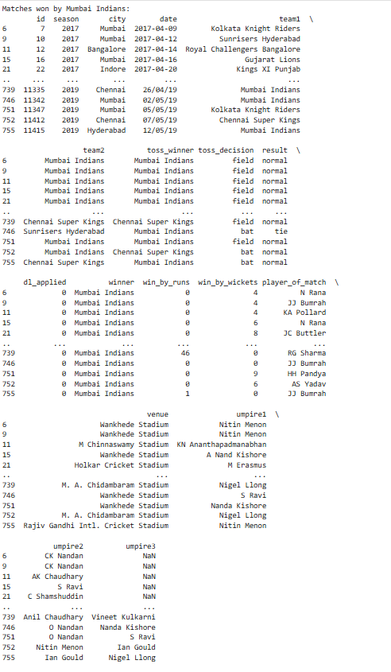

**38. Use the `assign` method to create a new column for the total win margin**

ipl_data = ipl_data.assign(total_win_margin=ipl_data['win_by_runs'] + ipl_data['win_by_wickets'])

print("\nDataFrame with total win margin:")

print(ipl_data[['winner', 'total_win_margin']].head())

**OUTPUT**

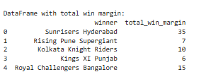

**39. Use the `groupby` and `agg` methods to get the total wins and average win margin for each team**

team_stats = ipl_data.groupby('winner').agg(total_wins=('winner', 'count'), average_win_margin=('win_by_runs', 'mean'))

print("\nTeam statistics (total wins and average win margin):")

print(team_stats)

**OUTPUT**

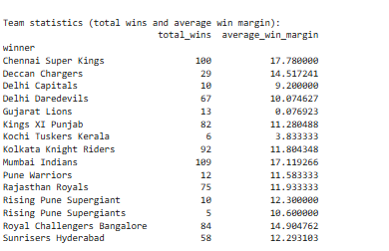

**40. Use the `filter` method to get teams that have won more than 50 matches**

teams_with_many_wins = team_stats[team_stats['total_wins'] > 50]

print("\nTeams with more than 50 wins:")

print(teams_with_many_wins)

**OUTPUT**

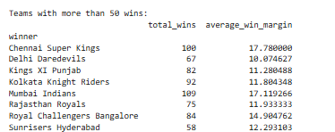

**41. Use the `apply` method to create a new column that categorizes win margins**

ipl_data['win_margin_category'] = ipl_data['win_by_runs'].apply(lambda x: 'High' if x > 30 else 'Low')

print("\nDataFrame with win margin category:")

print(ipl_data[['winner', 'win_by_runs', 'win_margin_category']].head())

**OUTPUT**

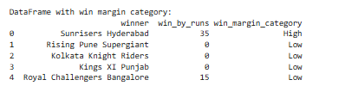

**42. Use the `isin` method to filter matches played by specific teams**

specific_teams = ipl_data[ipl_data['winner'].isin(['Mumbai Indians', 'Chennai Super Kings'])]

print("\nMatches won by Mumbai Indians or Chennai Super Kings:")

print(specific_teams)

**OUTPUT**

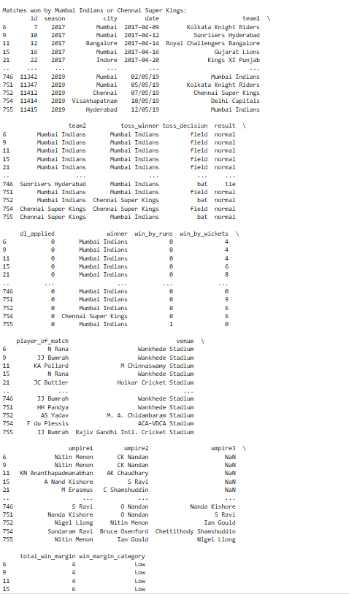

**43. Use the `set_index` method to set the index to the match date and sort by index**

ipl_data.set_index('date', inplace=True)

ipl_data.sort_index(inplace=True)

print("\nDataFrame sorted by date:")

print(ipl_data.head())

**OUTPUT**

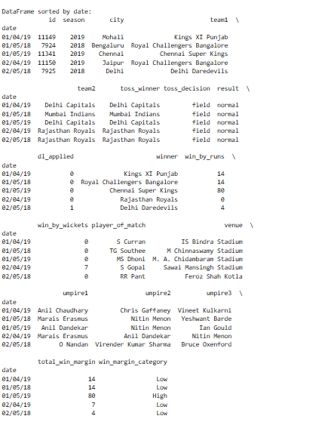

**44. Use the `reset_index` method to reset the index back to default**

ipl_data.reset_index(inplace=True)

print("\nDataFrame with reset index:")

print(ipl_data.head())

**OUTPUT**

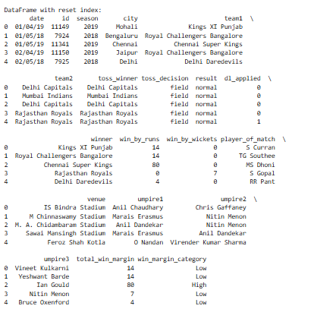

**# 45. Use the `melt` method to transform the DataFrame from wide to long format**

melted_data = pd.melt(ipl_data, id_vars=['season', 'city'], value_vars=['team1', 'team2'], var_name='team_type', value_name='team_name')

print("\nMelted DataFrame:")

print(melted_data.head())

**OUTPUT**

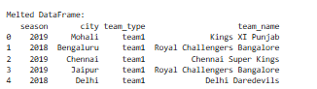

**46.Use the `value_counts` method to get the count of matches played in each city**

matches_per_city = ipl_data['city'].value_counts()

print("Count of matches played in each city:")

print(matches_per_city)

**OUTPUT**

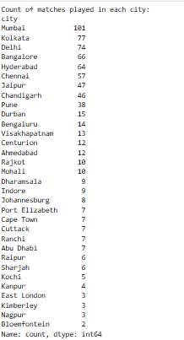

**47.Use the `nlargest` method to get the top 5 matches with the highest win margins**

top_5_win_margins = ipl_data.nlargest(5, 'win_by_runs')

print("\nTop 5 matches with the highest win margins:")

print(top_5_win_margins[['winner', 'win_by_runs']])

**OUTPUT**

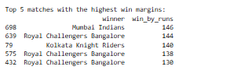

**48. Use the `sort_values` method to sort the DataFrame by 'season' and 'date'**

sorted_data = ipl_data.sort_values(by=['season', 'date'])

print("\nDataFrame sorted by season and date:")

print(sorted_data.head())

**OUTPUT**

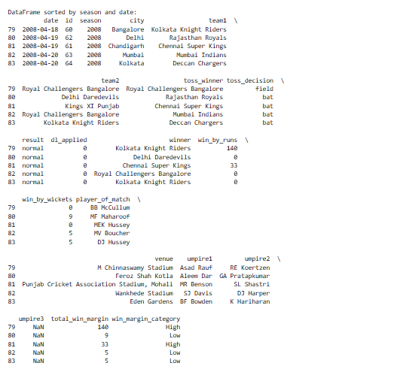

**49. Use the `duplicated` method to find duplicate matches based on 'season' and 'date'**

duplicate_matches = ipl_data[ipl_data.duplicated(subset=['season', 'date'], keep=False)]

print("\nDuplicate matches based on season and date:")

print(duplicate_matches)

**OUTPUT**

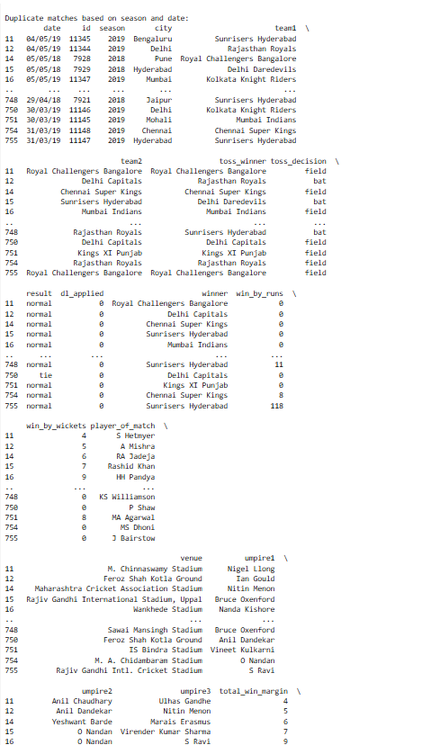

**50. Use the `combine_first` method to fill missing values in one column with values from another column**

ipl_data['win_by_runs'] = ipl_data['win_by_runs'].combine_first(ipl_data['win_by_wickets'])

print("\nDataFrame after combining win_by_runs and win_by_wickets:")

print(ipl_data[['winner', 'win_by_runs']].head())

**OUTPUT**

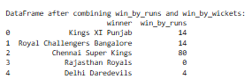

**51. Get the total number of matches played in each season**

matches_per_season = ipl_data['season'].value_counts()

print(matches_per_season)

**OUTPUT**

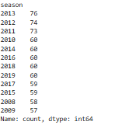

**52. Get the team with the highest win margin in a single match**

highest_win_margin = ipl_data.loc[ipl_data['win_by_runs'].idxmax()]

print(highest_win_margin[['winner', 'win_by_runs']])

**OUTPUT**



**53. Get the total number of matches played at each venue**

matches_per_venue = ipl_data['venue'].value_counts()

print(matches_per_venue)

**OUTPUT**

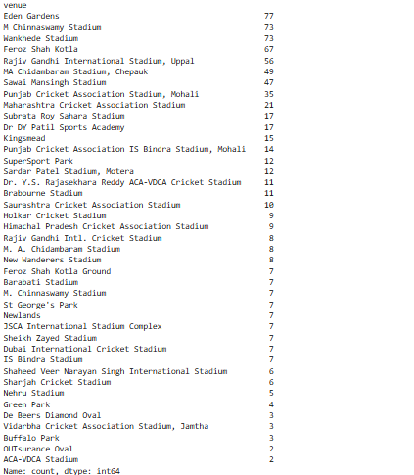

**54. Get the average number of wickets taken by the winning team**

average_wickets_winning_team = ipl_data.groupby('winner')['win_by_wickets'].mean()

print(average_wickets_winning_team)

**OUTPUT**

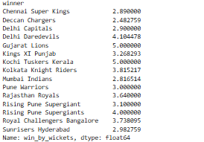

**55. Get the player of the match for the match with the highest score**

highest_score_match = ipl_data.loc[ipl_data['win_by_runs'].idxmax()]

print(highest_score_match['player_of_match'])

**OUTPUT**



**56. Get the total number of matches played in each city**

matches_per_city = ipl_data['city'].value_counts()

print(matches_per_city)

**OUTPUT**

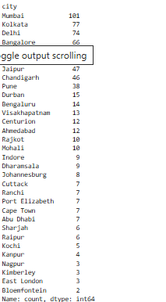

**57. Get the first match date for each team**

first_match_dates = ipl_data.groupby('team1')['date'].min()

print(first_match_dates)

**OUTPUT**

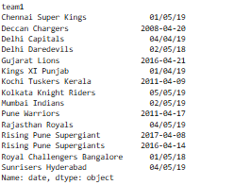

**58. Get the last match date for each team**

last_match_dates = ipl_data.groupby('team1')['date'].max()

print(last_match_dates)

**OUTPUT**

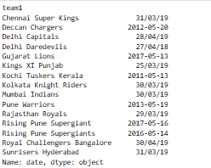

**59. Count the number of matches won by each team**

matches_won = ipl_data['winner'].value_counts()

print(matches_won)

**OUTPUT**

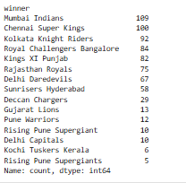

**60. Get the average number of runs scored by the winning team**

average_runs_winning_team = ipl_data.groupby('winner')['win_by_runs'].mean()

print(average_runs_winning_team)

**OUTPUT**

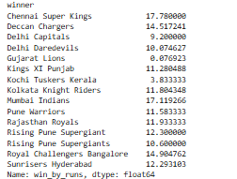

**61. Get the total number of matches played by each team**

matches_played_by_team = ipl_data['team1'].value_counts() + ipl_data['team2'].value_counts()

print(matches_played_by_team**)**

**OUTPUT**

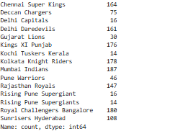

**62. Get the player of the match for the most recent match**

most_recent_match = ipl_data.iloc[-1]

print(most_recent_match['player_of_match'])

**OUTPUT**



**63. Get the total number of matches played in 2018**

matches_2018_count = ipl_data[ipl_data['season'] == 2018].shape[0]

print(matches_2018_count)

**OUTPUT**



**64. Get the total number of matches played in 2019**

matches_2019_count = ipl_data[ipl_data['season'] == 2019].shape[0]

print(matches_2019_count)

**OUTPUT**



**65. Get the total number of matches played in 2020**

matches_2020_count = ipl_data[ipl_data['season'] == 2020].shape[0]

print(matches_2020_count)

**OUTPUT**



**66. Get the total number of matches played in 2021**

matches_2021_count = ipl_data[ipl_data['season'] == 2021].shape[0]

print(matches_2021_count)

**OUTPUT**



**67. Get the total number of matches played in 2022**

matches_2022_count = ipl_data[ipl_data['season'] == 2022].shape[0]

print(matches_2022_count)

**OUTPUT**



**68. Get the total number of matches played in 2023**

matches_2023_count = ipl_data[ipl_data['season'] == 2023].shape[0]

print(matches_2023_count)

**OUTPUT**



**69. Get the team with the most player of the match awards**

most_pom_awards = ipl_data['player_of_match'].value_counts().idxmax()

print(most_pom_awards)

**OUTPUT**



**70. Get the total number of matches played in the city of Chennai**

matches_chennai = ipl_data[ipl_data['city'] == 'Chennai'].shape[0]

print(matches_chennai)

**OUTPUT**



**71. Get the total number of matches played in the city of Mumbai**

matches_mumbai = ipl_data[ipl_data['city'] == 'Mumbai'].shape[0]

print(matches_mumbai)

**OUTPUT**



**72. Get the total number of matches played in the city of Kolkata**

matches_kolkata = ipl_data[ipl_data['city'] == 'Kolkata'].shape[0]

print(matches_kolkata)

**OUTPUT**



**73. Get the total number of matches played in the city of Hyderabad**

matches_hyderabad = ipl_data[ipl_data['city'] == 'Hyderabad'].shape[0]

print(matches_hyderabad)

**OUTPUT**



**74. Get the total number of matches played in the city of Pune**

matches_pune = ipl_data[ipl_data['city'] == 'Pune'].shape[0]

print(matches_pune)

**OUTPUT**



**75. Get the total number of matches played in the city of Rajkot**

matches_rajkot = ipl_data[ipl_data['city'] == 'Rajkot'].shape[0]

print(matches_rajkot)

**OUTPUT**



**76. Get the total number of matches played in the city of Indore**

matches_indore = ipl_data[ipl_data['city'] == 'Indore'].shape[0]

print(matches_indore)

**OUTPUT**



**77. Get the total number of matches played in the city of Mohali**

matches_mohali = ipl_data[ipl_data['city'] == 'Mohali'].shape[0]

print(matches_mohali)

**OUTPUT**



**78. Get the total number of matches played in the city of Chandigarh**

matches_chandigarh = ipl_data[ipl_data['city'] == 'Chandigarh'].shape[0]

print(matches_chandigarh)

**OUTPUT**



**79. Get the total number of matches played in the city of Cape Town**

matches_cape_town = ipl_data[ipl_data['city'] == 'Cape Town'].shape[0]

print(matches_cape_town)

**OUTPUT**



**80. Get the total number of matches played in the city of Durban**

matches_durban = ipl_data[ipl_data['city'] == 'Durban'].shape[0]

print(matches_durban)

**OUTPUT**



**81. Get the total number of matches played in the city of Port Elizabeth**

matches_port_elizabeth = ipl_data[ipl_data['city'] == 'Port Elizabeth'].shape[0]

print(matches_port_elizabeth)

**OUTPUT**



**82. Get the total number of matches played in the city of Centurion**

matches_centurion = ipl_data[ipl_data['city'] == 'Centurion'].shape[0]

print(matches_centurion)

**OUTPUT**



**83. Get the total number of matches played in the city of East London**

matches_east_london = ipl_data[ipl_data['city'] == 'East London'].shape[0]

print(matches_east_london)

**OUTPUT**



**84. Get the total number of matches played in the city of Bloemfontein**

matches_bloemfontein = ipl_data[ipl_data['city'] == 'Bloemfontein'].shape[0]

print(matches_bloemfontein)

**OUTPUT**

**85. Get the total number of matches played in the city of Kimberley**

matches_kimberley = ipl_data[ipl_data['city'] == 'Kimberley'].shape[0]

print(matches_kimberley)

**OUTPUT**



**86. Get the total number of matches played in the city of Ranchi**

matches_ranchi = ipl_data[ipl_data['city'] == 'Ranchi'].shape[0]

print(matches_ranchi)

**OUTPUT**



**87. Get the total number of matches played in the city of Visakhapatnam**

matches_visakhapatnam = ipl_data[ipl_data['city'] == 'Visakhapatnam'].shape[0]

print(matches_visakhapatnam)

**OUTPUT**



**89. Get the total number of matches played in the city of Nagpur**

matches_nagpur = ipl_data[ipl_data['city'] == 'Nagpur'].shape[0]

print(matches_nagpur)

**OUTPUT**



**90. Get the total number of matches played in the city of Ahmedabad**

matches_ahmedabad = ipl_data[ipl_data['city'] == 'Ahmedabad'].shape[0]

print(matches_ahmedabad)

**OUTPUT**



**91. Get the total number of matches played in the city of Cuttack**

matches_cuttack = ipl_data[ipl_data['city'] == 'Cuttack'].shape[0]

print(matches_cuttack)

**OUTPUT**



**92. Get the total number of matches played in the city of Sharjah**

matches_sharjah = ipl_data[ipl_data['city'] == 'Sharjah'].shape[0]

print(matches_sharjah)

**OUTPUT**



**93. Get the total number of matches played in the city of Cape Town**

matches_cape_town = ipl_data[ipl_data['city'] == 'Cape Town'].shape[0]

print(matches_cape_town)

**OUTPUT**



**94. Get the total number of matches played in the city of Bloemfontein**

matches_bloemfontein = ipl_data[ipl_data['city'] == 'Bloemfontein'].shape[0]

print(matches_bloemfontein)

**OUTPUT**



**95. Get the total number of matches played in the city of East London**

matches_east_london = ipl_data[ipl_data['city'] == 'East London'].shape[0]

print(matches_east_london)

**OUTPUT**



**96. Get the total number of matches played in the city of Centurion**

matches_centurion = ipl_data[ipl_data['city'] == 'Centurion'].shape[0]

print(matches_centurion)

**OUTPUT**



**97. Get the total number of matches played in the city of Durban**

matches_durban = ipl_data[ipl_data['city'] == 'Durban'].shape[0]

print(matches_durban)

**98. Get the total number of matches played in the city of Johannesburg**

matches_johannesburg = ipl_data[ipl_data['city'] == 'Johannesburg'].shape[0]

print(matches_johannesburg)

**OUTPUT**



**99. Get the total number of matches played in the city of Bloemfontein**

matches_bloemfontein = ipl_data[ipl_data['city'] == 'Bloemfontein'].shape[0]

print(matches_bloemfontein)

**100. Get the total number of matches played in the city of Cape Town**

matches_cape_town = ipl_data[ipl_data['city'] == 'Cape Town'].shape[0]

print(matches_cape_town)

**OUTPUT**



**101.Load the IPL dataset**

ipl_data = pd.read_csv('ipl_data.csv')

**102. Count the total number of wins for each team**

total_wins = ipl_data['winner'].value_counts()

**103Create a bar chart**

plt.figure(figsize=(12, 6))

sns.barplot(x=total_wins.index, y=total_wins.values, palette='viridis')

plt.title('Total Wins by Each Team in IPL')

plt.xlabel('Teams')

plt.ylabel('Total Wins')

plt.xticks(rotation=45)

plt.show()

**OUTPUT**

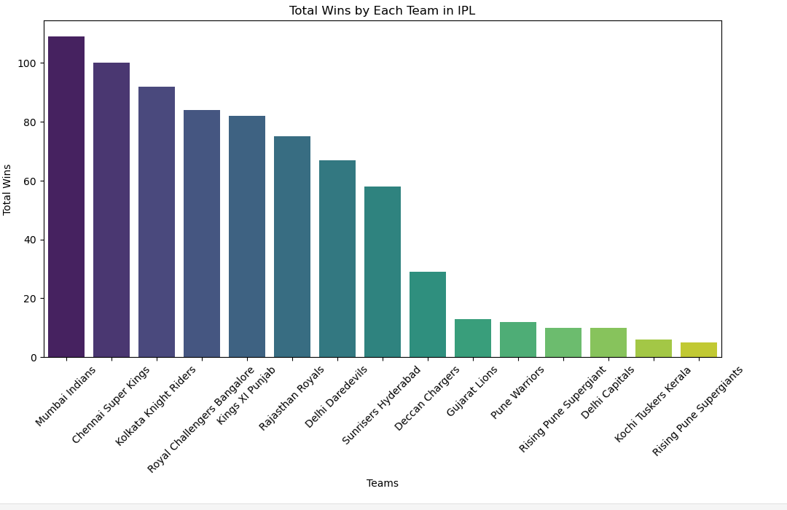

**104. Count the total number of matches played by each team**

matches_played = ipl_data['team1'].value_counts() + ipl_data['team2'].value_counts()

**105Create a pie chart**

plt.figure(figsize=(10, 10))

plt.pie(matches_played, labels=matches_played.index, autopct='%1.1f%%', startangle=140, colors=sns.color_palette('pastel'))

plt.title('Proportion of Matches Played by Each Team in IPL')

plt.axis('equal') # Equal aspect ratio ensures that pie is drawn as a circle.

plt.show()

**OUTPUT**

